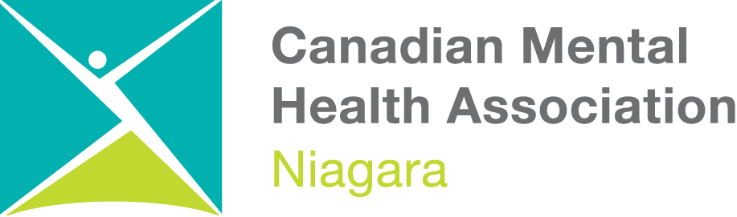
CMHA NIAGARA COMPLAINT FORM
Every Client, Family Member and Service Provider has the right to issue a formal complaint concerning services, safety or privacy concerns related to CMHA Niagara. Assistance can be requested for completing this form.
All complaints are confidential and will not affect quality or access to services for any individual.
Date:

Client Name: (if applicable)

Person Filing Complaint:

Relationship to Client:
(if applicable)

Address:

Contact information: | Telephone Number: Home:  Cell:  Other:  Permission to leave a message? Yes No  Email address:
Complaint Details:

Date and time of incident?
What happened?
Who was involved?
Where did it happen?
How did it happen?
Witnesses?
Who was notified?
What actions have already been taken?
Any other comments?

Desired Outcome or What could have been done differently to prevent concern?

X
Signature of Person Filing Complaint

Completed form to be given to Program Manager of involved program. If unsure how to submit or to whom, please call 905-641-5222 to inquire regarding appropriate person related to program of concern.

OFFICE USE

Person Receiving Complaint:
Date Received
Action Taken:

Resolved: YES NO

If Yes:
Summary of Agreed Upon Solution to Complaint

If No: Forward the complaint to the Quality Manager and/or Executive Director, according to Policy 200.02 – Client Complaint Protocol

Complainant Advised of Resolution or Next Steps? YES NO

Date:

X
Program Manager: Print then Sign Name

